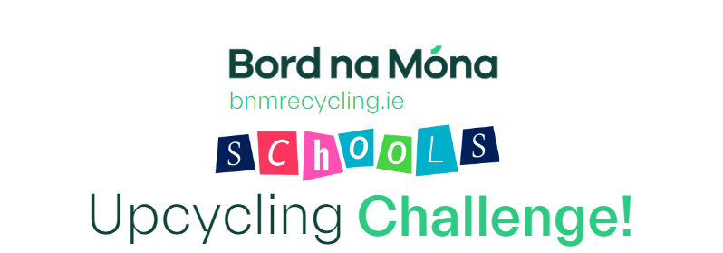

School Name:
Address of school:

Contact Number:
Email:
Teacher Involved:
First name of Child/Children:
Class year:

I have attached at least 2 pictures of the creation.

I agree to the terms and conditions of the Bord na

Móna Recycling Schools Upcycling Competition.

Please email completed application form and at least 2 pictures of the creation to marketing@bnm.ie - Closing date for entries 01/05/24
Terms & Conditions
1. By entering this competition, you agree to accept and be bound by these terms and conditions. All entry instructions form part of the terms and conditions of this competition. Entries that do not comply may be disqualified.
2. This competition is open to primary schools in the Republic of Ireland only to students aged 4 to 13 years on 1st of January 2024.
3. Entries must feature materials that are typically considered waste or used.
4. Only one entry per student is permitted. This may come as part of a team or an individual entry.
5. Entries must not contain hazardous waste or any material that could harm students.
6. Unsuccessful entrants/schools will receive a certificate via email.
7. It is not possible for feedback to be provided for unsuccessful entries.
8. No corrections or alterations can be made after receipt of an entry.
9. All entries must be the original work of the entrants and must not infringe the rights of any other party.
10. Entry opens on the 15th of January 2024. Entry closes at 5pm on the 1st of May 2024. Entries received after the closing date will not be considered.
11. Details on the prizes can be found on our website www.bnmrecycling.ie
12. Events may occur which render the awarding of the prizes impossible due to reasons beyond the control of Bord na Móna Recycling and Bord na Móna Recycling may vary, amend or suspend any of the prizes
13. Bord na Móna Recycling will only use data submitted by entrants for the purposes as set out in Bord na Móna Recycling’s privacy policy which can be found on our website www.bnmrecycling.ie
14. The winning school agrees to Bord na Móna Recycling’s use of their name, their entrants name(s) and project images in relation to Bord na Móna Recycling’s publicity material.
15. Details of the winner will be published on Bord na Móna Recycling’s website, social media pages and newsletter.
16.Bord na Móna Recycling reserves the right to amend these terms and conditions or cancel this competition at any stage, if deemed necessary in its opinion, or if circumstances arise outside of its control.
17. No alternative prize or cash alternative will be offered.
18. The €5000 prize will be awarded to the winning school, and not the individual students.

